H.T No
Regulations:
A14

Sreenidhi Institute of Science and Technology
(An Autonomous Institution)
Code No: 4FC17 Date: 01-Oct-2021(AN)

B.Tech III-Year II- Semester External Examination, Sept/Oct - 2021 (Supplementary)
THEORY OF COMPUTATION (ECM)

Time: 3 Hours Max.Marks:70

Note: a) No additional answer sheets will be provided.
b) All sub-parts of a question must be answered at one place only, otherwise it will not be valued.
c) Missing data can be assumed suitably.

ANSWER ANY 5 OUT OF 8 QUESTIONS. EACH QUESTION CARRIES 14 MARKS.

Bloom's Cognitive Levels of Learning (BCLL)

Remember | L1 | Apply | L3 | Evaluate | L5
Understand | L2 | Analyze | L4 | Create | L6

 |  |  | BCLL | CO(s) | Marks
1. | a) | Design DFA accepting the language whose binary interpretation is divisible by 5 over the alphabet {0, 1}. | L3 | CO1 | [7M]
 | b) | Design a NFA which contains 101 as a substring over an alphabet {0, 1}. | L2 | CO1 | [7M]
2. | a) | Construct a minimum state automaton equivalent to the finite automaton.  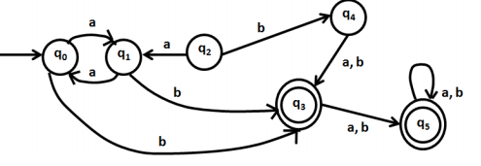 | L1 | CO2 | [10M]
 | b) | Construct an equivalent DFA for a NDFA M = ({q1, q2, q3}, q1, q3) where δ is  given by δ(q1,0)={ q2,q3 }, δ(q1,1)={ q1 }, δ(q2,0)={ q1,q2 }, δ(q2,1)= ∅,  δ(q3,0)={ q2} , δ(q3,1)={ q1,q2 } | L3 | CO2 | [4M]
3. | a) | Construct regular expression for the given DFA.  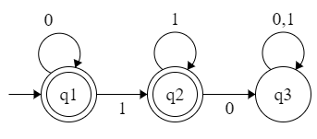 | L5 | CO3 | [7M]
 | b) | Obtain a Right Linear Grammar for the language L = {a^{n} b^{m} | n>=2 , m>=3} | L3 | CO3 | [7M]
4. | a) | Check whether the given grammar is ambiguous or not.  S→ iCtS  S→ iCtSeS  S→ a  C→ b | L5 | CO4 | [7M]
 | b) | Design PDA for L={wcw^{r} | w ϵ (0+1)* } | L3 | CO4 | [7M]
5. | a) | Explain computable functions. | L4 | CO5 | [7M]
 | b) | Design a Turing Machine to addition of 2 integers. | L3 | CO5 | [7M]
6. | a) | Explain Chomsky hierarchy of languages | L3 | CO6 | [7M]
 | b) | Determine whether the following PCP problem has a solution or not.  X={b,babbb,ba} Y={bbb,ba,a} | L5 | CO6 | [7M]
7. | a) | Define string, alphabet and language. | L5 | CO1 | [7M]
 | b) | Construct a Mealy machine which is equivalent to the Moore machine.  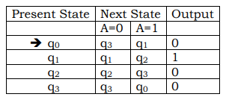 | L3 | CO2 | [7M]
8. | a) | Convert the following Context Free Grammar to Push down automata.  S→ aAA  A→aS | bS | a | L2 | CO4 | [7M]
 | b) | Explain model of TM. | L3 | CO5 | [7M]

-- 00 -- 00 –

